**Experiment -1.2**

Design and implement a simple inventory control system for a small video rental store

**Student Name: Parikshit sharma UID:19BCS4520**

**Branch: CSE-IOT-1 Section/Group:A**

**Semester: 4**

**Date of Performance:15-02-2021**

**Subject Name: PROJECT BASED LEARNING IN JAVA Subject Code:CSP-296P**

**1. Aim/Overview of the practical: Design and implement a simple inventory control system for a small video rental store**

**2. Task to be done: The following are the various classes and member functions and design the functions that are to be implemented**

**1. Video**

**2. Videostore**

**3. Videolauncher**

**3. Apparatus(For applied/experimental sciences/materials based labs):**

**Java compiler like Java netbeans or eclipse etc.**

**4. Algorithm/Flowchart (For programming based labs):**

**Step-1: Firstly we need to open the new project in java netbeans compiler.**

**Step-2: Now we need to create the individual classes like Video ,Video launcher, Videostore.**

**Step-3: Create the member functions like Add video, Checkout Videos ,Return Videos,**

**Receive Rating, List inventory ,exit.**

**Step-4: Create a relationship between the pages and their functions in the project.**

**Step-5: Use switch case for the case.**

**Step-6: Make sure that there are no errors.**

**Step-7: Now execute the code and check.**

**Step-8: Make your choice to view the output.**

**5. Theme/Interests definition( For creative domains):**

* **Java is an object-oriented programming language.**

* **Everything in Java is associated with classes and objects, along with its attributes and methods. For example: in real life, a car is an object. The car has attributes**, **such as weight and color, and methods, such as drive and brake.**
* **A Class is like an object constructor, or a "blueprint" for creating objects.**
* **It allows the data to be in a planned manner.**
* **To create a class, use the keyword ‘class:’**
* **Create a class named "Main" with a variable x:**
* **In Java, an object is created from a class. We have already created the class named MyClass, so now we can use this to create objects.**
* **To create an object of MyClass, specify the class name, followed by the object name, and use the keyword new:**
* **Create an object called "myObj" and print the value of x:**

**Member functions:**

* **A member function of a class is a function that has its definition or its prototype within the class definition like any other variable. It operates on any object of the class of which it is a member, and has access to all the members of a class for that object.**
* **The variables which are declared in any class by using any fundamental data types (like int, char, float etc) or derived data type (like class, structure, pointer etc.) are known as Data Members. And the functions which are declared either in private section of public section are known as Member functions.**
* **An object may contain values which are stored internally and are unique to that object. A data member may be of any type, including classes already defined, pointers to objects of any type, or even references to objects of any type.**

**6. Steps for experiment/practical:**

**Step-1: Firstly we need to open the new project in java netbeans compiler.**

**Step-2: Now we need to create the individual classes like Video ,Video launcher, Videostore.**

**Step-3: Create the member functions like Add video, Checkout Videos ,Return Videos,**

**Receive Rating, List inventory ,exit.**

**Step-4: Create a relationship between the pages and their functions in the project.**

**Step-5: Use switch case for the case.**

**Step-6: Make sure that there are no errors.**

**Step-7: Now execute the code and check.**

**Step-8: Make your choice to view the output.**

**7. Observations/Discussions:**

**In this while running the code you will get a dialogue box to select in which you wanted to view:**

**For adding videos enter 1**

**For check out -2**

**For return video-3**

**For receiving rating-4**

**For list inventory-5**

**For exit -6**

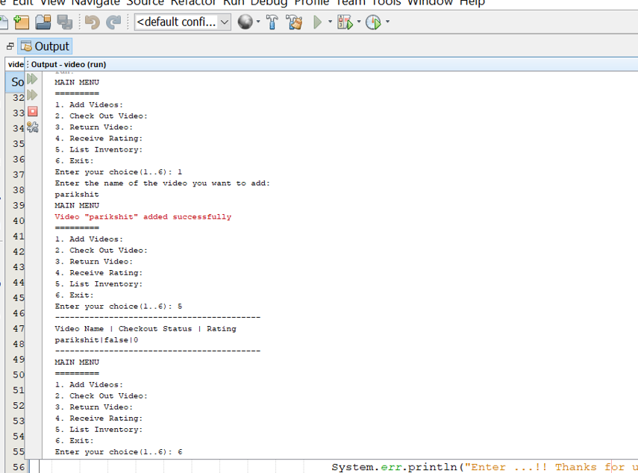

**8. Percentage error (if any or applicable): Nothing**

**9. Calculations/ Chemical Reactions / Theorems /Formulas Source code used etc :**

**1 Vedio**

**/\***

**\* To change this license header, choose License Headers in Project Properties.**

**\* To change this template file, choose Tools | Templates**

**\* and open the template in the editor.**

**\*/**

**package videoo;**

**/\*\***

**\***

**\* @author dell**

**\*/**

**public class videoo {**

**String videoName;**

**boolean checkout;**

**int rating;**

**public videoo() {**

**}**

**public videoo(String name)**

**{**

**videoName=name;**

**}**

**public String getName()**

**{**

**return videoName;**

**}**

**public void doCheckout()**

**{**

**System.err.println("Video "+'"'+ getName()+'"' +" checked out successfully.");**

**}**

**public void doReturn()**

**{**

**checkout=true;**

**System.err.println("Video "+'"'+ getName()+'"' +" returned successfully.");**

**}**

**public void receiveRating(int rating)**

**{**

**this.rating=rating;**

**}**

**public int getRating()**

**{**

**return rating;**

**}**

**public boolean getCheckout()**

**{**

**return checkout;**

**}**

**}**

**//Vediostore**

**/\***

**\* To change this license header, choose License Headers in Project Properties.**

**\* To change this template file, choose Tools | Templates**

**\* and open the template in the editor.**

**\*/**

**/\*\***

**\***

**\* @author dell**

**\*/**

**public class videostore {**

**videoo[] store;**

**public videostore() {**

**// TODO Auto-generated constructor stub**

**store=new videoo[5];**

**}**

**public void addVideo(String name)**

**{**

**store[0]=new videoo(name);**

**System.err.println("Video "+'"'+store[0].getName()+'"'+" added successfully");**

**}**

**public void doCheckout(String name)**

**{**

**if(store[0].videoName.equals(name))**

**{**

**store[0].doCheckout();**

**}**

**}**

**public void doReturn(String name)**

**{**

**if(store[0].videoName.equals(name))**

**{**

**store[0].doReturn();**

**}**

**}**

**public void receiveRating(String name, int rating) {**

**if(store[0].videoName.equals(name))**

**{**

**store[0].receiveRating(rating);**

**}**

**System.err.println("Rating "+'"'+store[0].getRating()+'"'+" has been mapped to the Video ''"+store[0].getName()+'"');**

**}**

**public void listInventory() {**

**System.out.println("------------------------------------------");**

**System.out.println("Video Name | Checkout Status | Rating");**

**System.out.println(store[0].getName()+"|" +store[0].getCheckout()+ "|"+ store[0].getRating());**

**System.out.println("------------------------------------------");**

**}**

**}**

**3 vediolauncher**

**import java.util.Scanner;**

**/\***

**\* To change this license header, choose License Headers in Project Properties.**

**\* To change this template file, choose Tools | Templates**

**\* and open the template in the editor.**

**\*/**

**/\*\***

**\***

**\* @author dell**

**\*/**

**public class videolauncher {**

**/\*\***

**\* @param args the command line arguments**

**\*/**

**public static void main(String[] args) {**

**try ( // TODO code application logic here**

**Scanner input = new Scanner(System.in)) {**

**int choice;**

**videostore videoStore=new videostore();**

**do {**

**System.out.println("MAIN MENU \n=========");**

**System.out.println("1. Add Videos:");**

**System.out.println("2. Check Out Video:");**

**System.out.println("3. Return Video:");**

**System.out.println("4. Receive Rating:");**

**System.out.println("5. List Inventory:");**

**System.out.println("6. Exit:");**

**System.out.print("Enter your choice(1..6): ");**

**choice=input.nextInt();**

**switch (choice) {**

**case 1:**

**System.out.println("Enter the name of the video you want to add: ");**

**videoStore.addVideo(input.next());**

**break;**

**case 2:**

**System.out.print("Enter the name of the video you want to check out: ");**

**videoStore.doCheckout(input.next());**

**break;**

**case 3:**

**System.out.print("Enter the name of the video you want to Return:");**

**videoStore.doReturn(input.next());;**

**break;**

**case 4:**

**System.out.println("Enter the name of the video you want to Rate: ");**

**videoStore.receiveRating(input.next(), input.nextInt());**

**break;**

**case 5:**

**videoStore.listInventory();**

**break;**

**case 6:**

**System.err.println("Enter ...!! Thanks for using the application");**

**System.exit(1);**

**break;**

**}**

**}while(!(choice==6));**

**}**

**}**

**}**

**10. Result/Output/Writing Summary:**

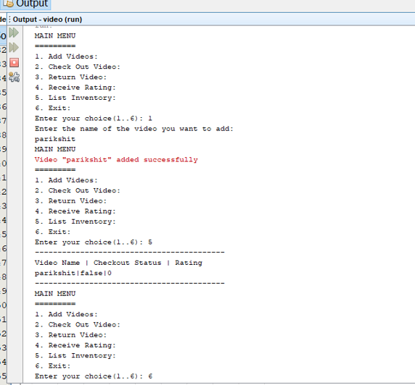

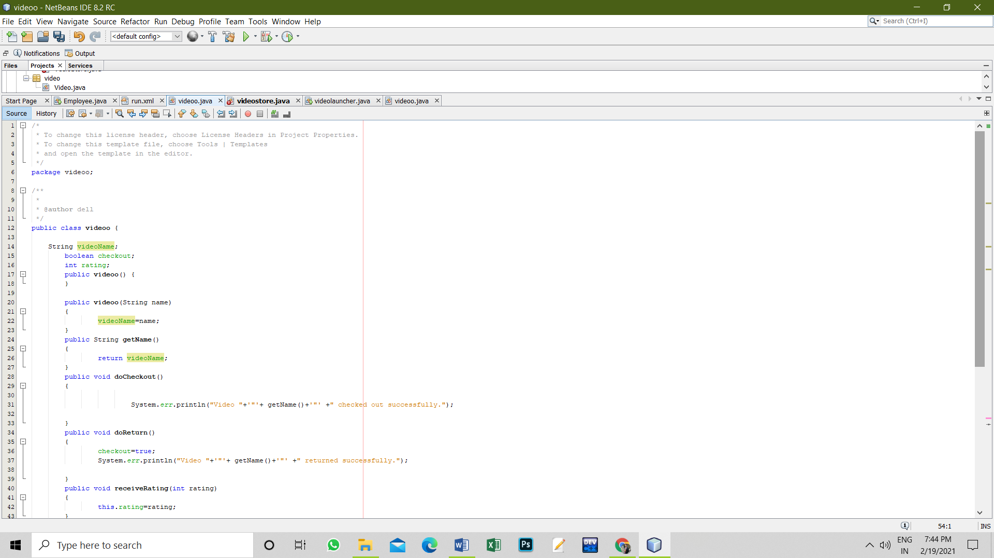

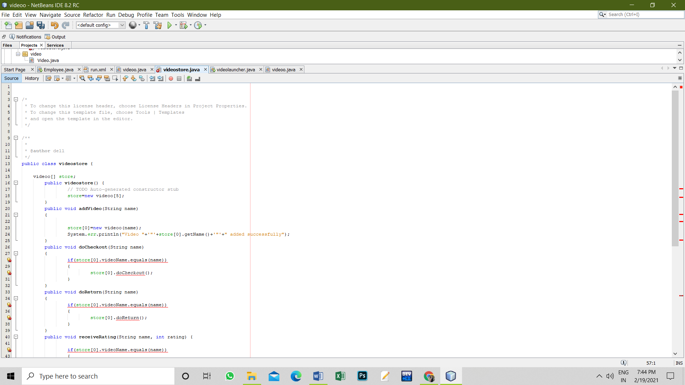

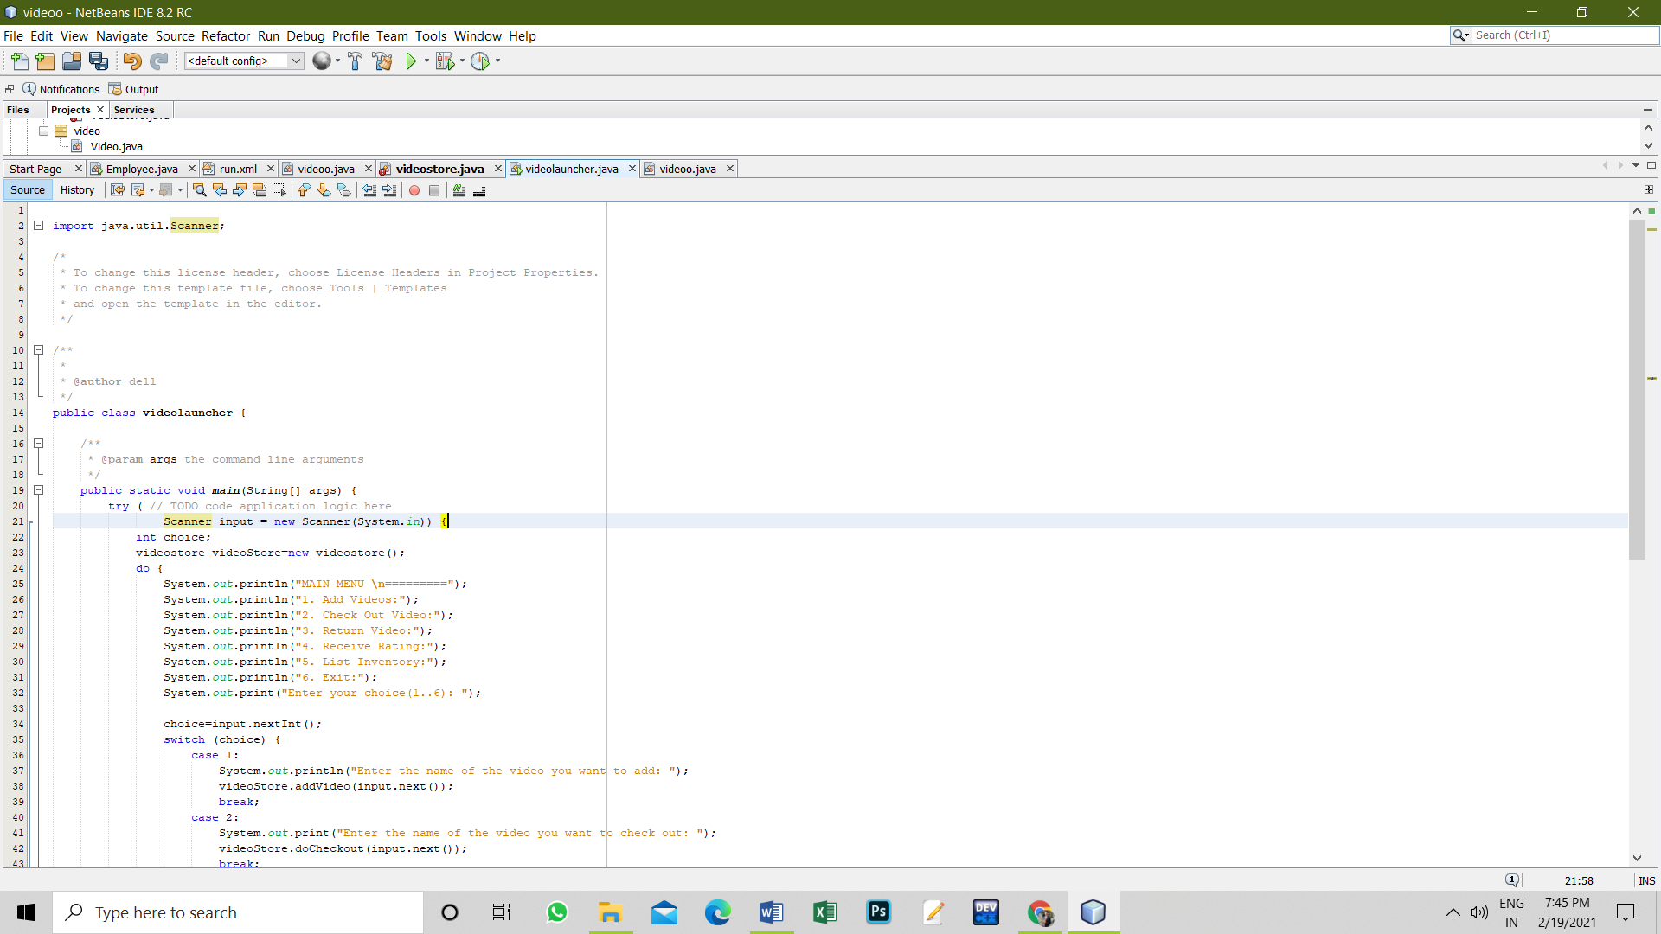

**11. Graphs (If Any): Image /Soft copy of graph paper to be attached here**

**Learning outcomes (What I have learnt):**

1. **I have learnt how to work on netbeans and create the projects and applications.**

**2. I have experienced in the syntax and how the switch case can be used in different applications.**

**3. I have learnt about the classes and member functions, objects in java.**

**4. I have learnt how to correct the errors in the code.**

**5. I have learnt how to execute and get the details according to our use and application.**

**Evaluation Grid (To be created as per the SOP and Assessment guidelines by the faculty):**

|  |  |  |  |
| --- | --- | --- | --- |
| Sr. No. | Parameters | Marks Obtained | Maximum Marks |
| 1. |  |  |  |
| 2. |  |  |  |
| 3. |  |  |  |
|  |  |  |  |